EXP.NO: 2 | Write JavaScript Programme to validate the following fields of the HTML Registration page.
DATE: 06/02/2025

AIM:
To write JavaScript code to validate user input in a registration form. The validation will ensure that the data entered by the user meets specific criteria for each field. This will help in maintaining data integrity and prevent invalid submissions.

ALGORITHM:
- Input:
  - The user fills in the following fields: First Name, Password, E-mail, Mobile Number, Last Name, and Address.

Validation Steps:
- Validate First Name:
  - Check if the first name contains only alphabets.
  - Ensure the length of the First Name is at least 6 characters.
  - If any of these conditions fail, display an error message indicating the required input.

Validate Password:
  - Check if the password is at least 6 characters long.
  - If it is less than 6 characters, display an error message.

Validate E-mail:
  - Use a regular expression to check if the email follows the standard pattern: name@domain.com.
  - Ensure that the email contains no invalid characters and matches the required pattern.
  - If it doesn't match, display an error message indicating an invalid email format.

Validate Mobile Number:
  - Check if the mobile number contains exactly 10 digits.
  - Ensure there are no alphabets or special characters.
  - If the number is invalid, display an error message indicating the correct format.

Validate Last Name:
  - Ensure the Last Name field is not empty.
  - If it is empty, display an error message.

Validate Address:
  - Ensure the Address field is not empty.
  - If it is empty, display an error message.

Code:

<!DOCTYPE html>
<html>
<head>
<title>AI & ML Department</title>

<style>
body {
margin: 0;
font-family: Arial;
background: linear-gradient(120deg,#0f2027,#203a43,#2c5364);
color: white;
}

header {
display: flex;
align-items: center;
padding: 15px;
background: #0006;
}

.logo {
width: 60px;
height: 60px;
border-radius: 50%;
background: linear-gradient(45deg,#00f260,#0575e6);
display: flex;
align-items: center;
justify-content: center;
font-size: 22px;
font-weight: bold;
}

h1 { margin-left: 15px; }

.box {
width: 380px;
margin: 40px auto;
padding: 20px;
background: #ffffff22;
border-radius: 10px;
}

input, textarea, button {
width: 100%;
padding: 10px;
margin: 6px 0;
border: none;
border-radius: 5px;
}

button {
background: #00f260;
font-weight: bold;
cursor: pointer;
}

#dept { display: none; text-align: center; padding: 50px; }

.logo2 {
width: 120px;
height: 120px;
margin: auto;
border-radius: 20px;
background: linear-gradient(135deg,#ff512f,#dd2476);
display: flex;
align-items: center;
justify-content: center;
font-size: 36px;
font-weight: bold;
}

.cards {
display: flex;
justify-content: center;
gap: 15px;
margin-top: 30px;
flex-wrap: wrap;
}

.card {
width: 200px;
background: #1e293b;
padding: 15px;
border-radius: 10px;
}
</style>

<script>
function validate() {
let f = fname.value;
let l = lname.value;
let p = pass.value;
let e = email.value;
let m = mobile.value;
let a = addr.value;

if (!/^[A-Za-z]{6,}$/.test(f)) {
alert("First name must be minimum 6 alphabets");
return false;
}
if (p.length < 6) {
alert("Password must be minimum 6 characters");
return false;
}
if (!/^[a-zA-Z0-9._]+@[a-zA-Z]+\.[a-zA-Z]{2,}$/.test(e)) {
alert("Invalid Email ID");
return false;
}
if (!/^[0-9]{10}$/.test(m)) {
alert("Mobile number must contain 10 digits");
return false;
}
if (l === "" || a === "") {
alert("Last name and address cannot be empty");
return false;
}

document.getElementById("reg").style.display = "none";
document.getElementById("dept").style.display = "block";
return false;
}
</script>
</head>

<body>

<header>
<div class="logo">AI</div>
<h1>Department of AI & ML</h1>
</header>

<div id="reg" class="box">
<h2>Registration</h2>
<form onsubmit="return validate()">
<input id="fname" placeholder="First Name">
<input id="lname" placeholder="Last Name">
<input id="pass" type="password" placeholder="Password">
<input id="email" placeholder="Email ID">
<input id="mobile" placeholder="Mobile Number">
<textarea id="addr" placeholder="Address"></textarea>
<button>Register</button>
</form>
</div>

<div id="dept">
<div class="logo2">AI&ML</div>
<h1>Welcome to AI & ML Department</h1>
<p>Innovation • Intelligence • Automation</p>

<div class="cards">
<div class="card"><h3>AI</h3><p>Smart Systems</p></div>
<div class="card"><h3>ML</h3><p>Machine Learning</p></div>
<div class="card"><h3>Careers</h3><p>Future Technology</p></div>
</div>
</div>

</body>
</html>

Output:

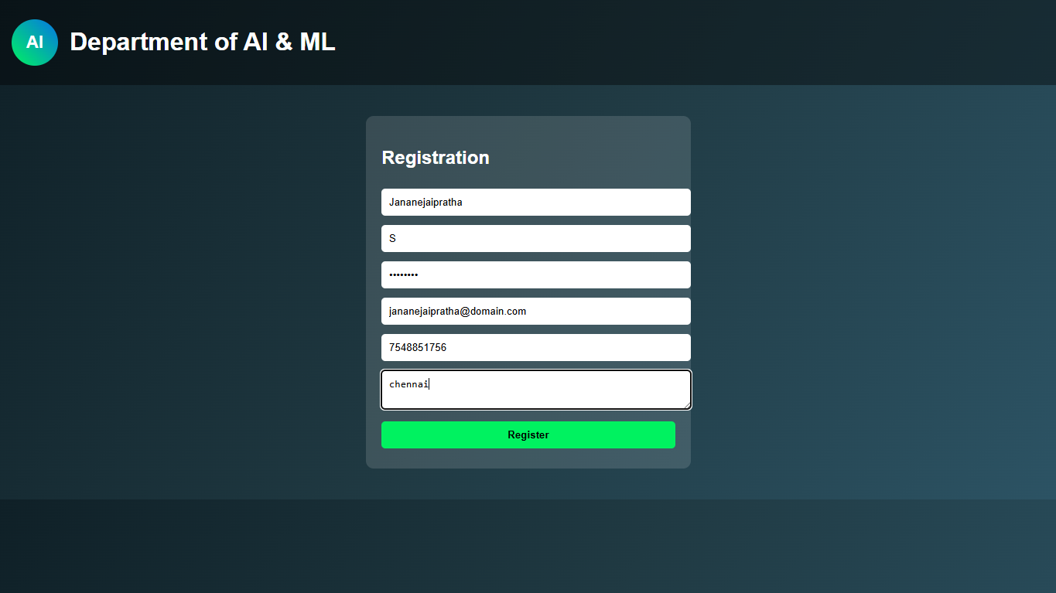



RESULT:
HTML page with Form is created and is validated using Javascript.

